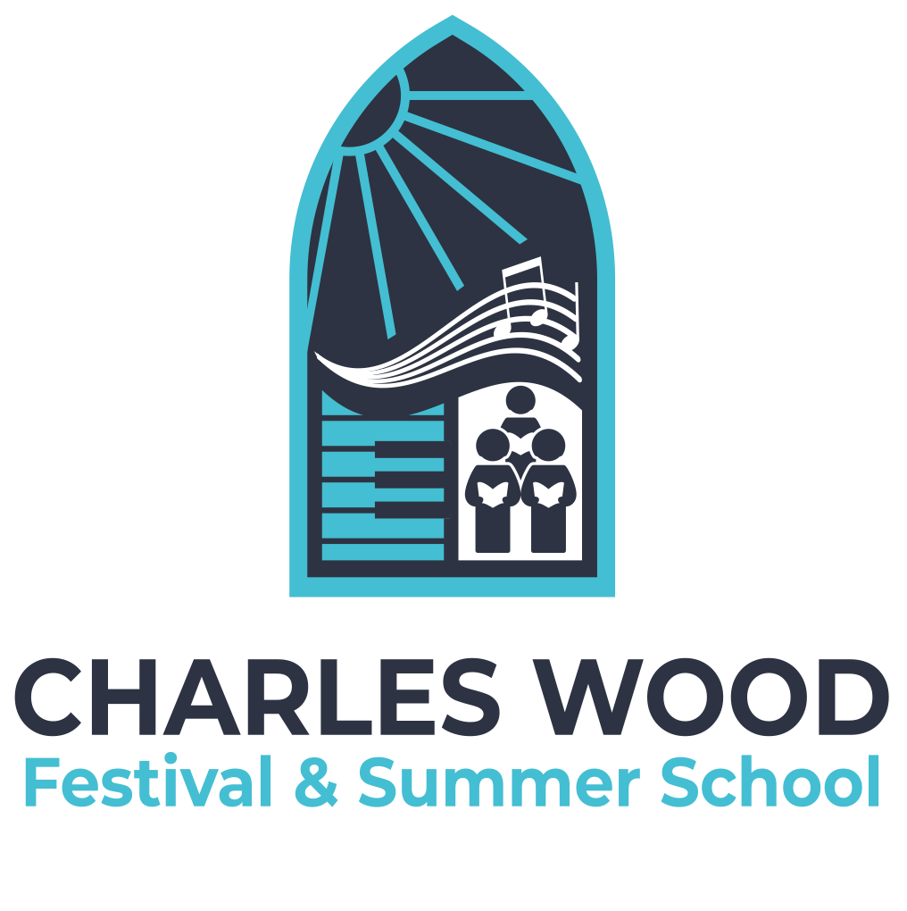
Charles Wood Summer School
Complaints
POLICY AND GUIDELINES

Revised May 2026

Statement of Intent
The Charles Wood Festival of Music and Summer School is committed to providing a positive, safe and professional environment for all participants, staff, volunteers, audience members and partners.

The Festival recognises that concerns or complaints may occasionally arise and is committed to responding fairly, respectfully and promptly.

This procedure outlines how complaints can be raised and managed.
What is a Complaint?
A complaint may relate to:
- The conduct of staff, volunteers or participants
- The delivery of Festival activities or events
- Communication or administration
- Equality, inclusion or accessibility concerns
- Health and safety issues
- Breaches of Festival policies or procedures

Safeguarding concerns should be reported immediately under the appropriate safeguarding procedures rather than through this complaints process.
Informal Resolution
Where appropriate, concerns should first be raised informally with the relevant member of staff, volunteer supervisor or Festival Manager.

Many issues can be resolved quickly through informal discussion and clarification.
Formal Complaints
If the matter cannot be resolved informally, a formal complaint may be submitted in writing to the Festival Manager or Board.

Complaints should include:
- The nature of the complaint
- Relevant dates, times or details
- Any actions already taken
- The outcome sought where appropriate

The Festival will aim to:
- Acknowledge complaints promptly
- Consider complaints fairly and confidentially
- Respond respectfully and proportionately
- Keep appropriate records

Investigation and Outcome
Where necessary, the Festival may:
- Speak to relevant individuals
- Review documentation or records
- Seek additional information

A written response will normally be provided within a reasonable timeframe where possible.

The Festival reserves the right to determine appropriate action following investigation.
Confidentiality
Complaints will be handled sensitively and confidentially where possible.

Information will only be shared with those who need to be involved in addressing the matter.
Malicious or Vexatious Complaints
Deliberately false, malicious or vexatious complaints may themselves be treated as a disciplinary matter.
Review of Procedure
This procedure was approved by the Board of the Charles Wood Festival of Music and Summer School in May 2026.

The procedure will be reviewed annually or earlier where required by changes in legislation or organisational practice.

